**Kol simcha torah gazette**

**For parshas ha’azinu 5784**

Volume 8, Issue 2 (Whole Number 360) 8 Tishrei 5783/ September 23, 2023

**Printed L’illuy nishmas Nechama bas R’ Noach, a”h**

For a free subscription, please forward your request to [***keren18@juno.com***](mailto:keren18@juno.com)

**Brownsville, Brooklyn: How Chabad Is Breathing New Jewish Life Into a Historically Multicultural Community**

**By** [**Rachel S. Kovacs**](https://www.jewishpress.com/author/rachel-s-kovacs/)

 -

[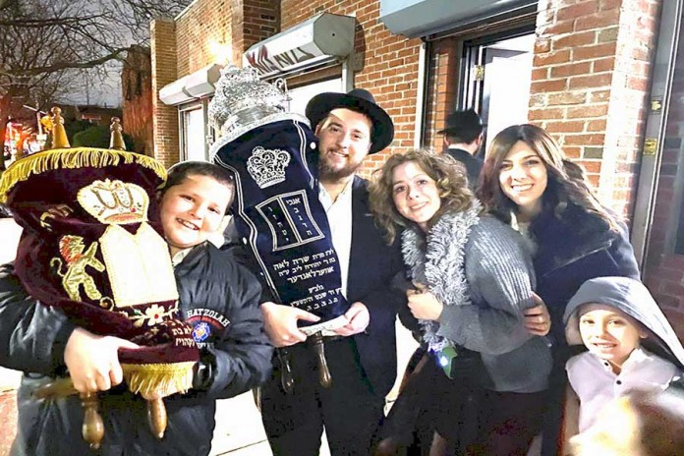](https://www.jewishpress.com/wp-content/uploads/2023/09/Kovacs-090823-Main.jpg)***The Overlander family at a sefer Torah dedication earlier this year.***

The spirit of Jewish Brownsville may once again be infused with new life. Since 2017, Orthodox families, mostly Chabad, have purchased homes with the intention of revitalizing the area, its multicultural traditions, and Jewish institutions. After taking a “deep dive” – interviewing residents and researching the area’s history – it’s clear how recent changes have set the stage for a viable, incrementally growing Orthodox presence there.

Brownsville, in the far-eastern section of Brooklyn, began in the 1600s as Dutch farmlands. Then settlers from England, Scotland, Ireland, and elsewhere built businesses and constructed homes in an expansive area of eastern and northern Brooklyn, which included Flatbush, Bedford Stuyvesant, East New York, Cypress Hills, New Lots, and Canarsie.

**From Ellis Island to the Lower East Side to Brownsville**

From the mid-1600s, a few Dutch-Brazilian Sephardic Jewish refugees, traders, and merchants resided in Flatbush/New Lots. It wasn’t until the mid-1800s that Bavarian German Jews emigrated in larger numbers to what had been a predominantly Anglo-European area. In the 1880s, Eastern European Jews fleeing pogroms came *en masse* to the U.S. Those whose port of entry was New York passed through Ellis Island and generally settled in the Lower East Side. From there, many chose Brownsville to be their home.

Between the mid-1880s and the mid-1920s (after which immigration quotas were reduced), a vibrant Brownsville hub developed. It was a booming community in the interwar period and thereafter, one that thrived spiritually and culturally, if not always materially, for Jews.

My grandparents, who emigrated from Europe, moved to Brownsville about 1908. They wanted to escape the decrepit Lower East Side tenements, where their older children were born, and infant daughter died. My father, the youngest of ten, was born at home on Herzl Street, nearly a generation later. This was but one of my family’s many Brownsville domiciles.

**A Stepping Stone to Upward Mobilityh**

For these “transplants” and scores of others, Brownsville was a steppingstone to upward mobility, a buffer between tenements with their “greeners” and the “classier” neighborhoods. Alfred Kazin’s moving memoir, *A Walker in the City*, provides a window into Brownsville’s unique sights, smells, and Jewish flavors; the contrasting focus of Alter F. Landesman’s *Brownsville* is on community institutions and their founders. Kazin recalls that prosperous residents, named “allrightniks” by the Brownsville locals who envied them, moved to Crown Heights.

Chabad’s Brownsville foothold there began with Rabbi Israel Jacobson, who led the Anshei Bobroisk synagogue. A *shliach* of Rabbi Yosef Yitzchak Schneersohn, he entered the U.S. in 1925 and became one of the first Lubavitcher emissaries here. Chabad was one of many groups that flourished during Brownsville’s heyday, which lasted until the late 1960s.

Then, when urban crime spiraled, incomes rose, and housing alternatives grew in Brooklyn, Queens, and Long Island, most of the community’s Jews exited. Their former presence, detectable in stained glass windows, Magen Davids, and outlines of mezuzahs visible in doorways, was partially obscured by newly adorned churches to which the synagogues were sold.

**Tackling the Community’s Reputation of a High Crime Area**

Fast forward to today and the question becomes: Why would Orthodox Jews, primarily Chabad, move into what for decades was known as a high crime area? It didn’t take long in my conversation with them for Rabbis Levi Vogel and Yossi Overlander, local residents active in the “Brownsville Anash,” to dispel the “high crime” characterization of the neighborhood. (Anash is an acronym for “*anshei shlomeinu*”*–*literally, “men of our place” – often viewed as a chassidic fraternity.)

They said that the streets are lined with one- or two-family homes where mostly older, churchgoing families, but some couples with younger children live.

Rabbi Vogel, a board member of the Anash, explained that from the late 1970s through the 1980s, there were many hi-rise, densely populated buildings in Brownsville. The government then decided to build small one-family homes, whose owners were working-class people of color, mostly from the Caribbean. Currently, there is one non-Chabad Orthodox family, and, Rabbi Vogel “guesstimates,” about 5% white, non-Jewish residents in the area.

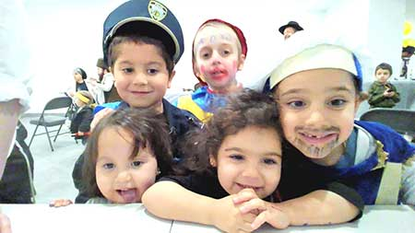

**Children on Purim in Brownsville, 2023.**

The main motivator for the Chabad families’ move is affordability. The cost of a 1,600 square foot one-family home in Brownsville runs about $550,000. A comparable home in nearby East Flatbush or Remsen Village, which have experienced a major Orthodox influx in the last several years, would cost about $750,000. Compare these with a $1,000,000, one-floor condo in Crown Heights. In Brownsville, a two-family house costs about $800,000. In East Flatbush, one would pay about $1,000,000. A comparable two-family house in Crown Heights costs about $1,400,000 or $1,500,000.

In addition to reduced housing costs, Brownsville homes have gardens, an appealing feature for families with children accustomed to asphalt sidewalks. There are also well-maintained parks nearby, and in 2021 the city renovated a running track. Throughout this area, there is positive interaction between people of color and whites. All the residents take great pride in their homes and community. It is quiet and non-violent, and the Orthodox and African American children ride their scooters concurrently. At one point concerned residents stopped a potentially raucous block party, organized by an outside group, from taking place on 12 consecutive Saturdays. After three weeks, homeowners signed a petition to stop the events.

**Opposed to the Concept of “Gentrification”**

Gentrification is a word Rabbi Overlander clearly dislikes, and when probed, both he and Rabbi Vogel say “no,” it’s not happening in Brownsville. There are no high-end stores where necessities are unaffordable, and no tenants forced from their homes by unscrupulous landlords to ease in wealthier tenants.

A small percentage of homes are being sold to Orthodox Jews. Word of mouth spreads, and families, who come to see the homes, the parks, and other resources, decide to buy. Rabbi Vogel is confident that last year’s trend, in which five families moved from Crown Heights, will continue. (Today, some 16 Orthodox families live in Brownsville.) One non-Chabad family moved from Queens, and Rabbi Vogel doesn’t envision an exclusively Chabad community.

There are no Jewish-owned establishments. Although Brownsville is in proximity to Crown Heights, there is a seven to eight block radius that is totally disconnected from it. Children take buses to school; Only Rabbi Overlander, principal of Ohr Menachem, a Crown Heights elementary school, drives his children there. Rabbi Vogel is employed part-time in *chinuch* but is primarily a businessman.

**A 30-Minute Walk to 770 Eastern Parkway**

There is neither a *mikvah* nor a community/shul rabbi yet in Brownsville, but the Anash fundraises to those ends. It takes 30 minutes to walk to 770 Eastern Parkway and half the time to reach the smaller shuls, so multiple options for *davening* exist, but there *is*a fully equipped Brownsville basement shul with a new *sefer Torah*, dedicated by the Overlander family.

Rabbi Avraham Schtroks, of the first Orthodox family to buy in Brownsville in 2017, owns the home and rents the shul to the Anash at a discount. There is a fund, Brownsville Anash Corp., where residents’ donations defray overhead and other expenses. The shul offers *shiurim*, holiday events, and, once or twice a month, programs for women and children.

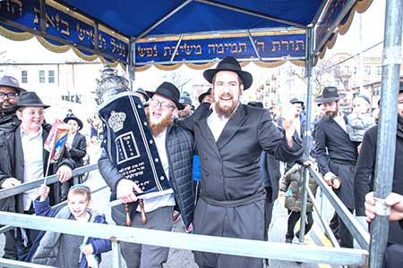

**Marching through the streets of Brownsville, Brooklyn, during Torah dedication and L’ag Ba’Omer parade, 2023.**

Restoring a Jewish presence in Brownsville is a slow process. Given economic realities and the potential to build a well-resourced community close to the Chabad heartland, the odds of doing so seem favorable. With the help of a small, cohesive core of dedicated householders paving the way, it’s likely to be an achievable goal.

*Reprinted from September 7, 2023 website of Chabad.Org*

**Rav Avigdor Miller on**

**Lost Love, Lasting Loyalty**

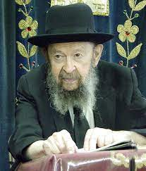

**QUESTION:** How should one react if they find that they don’t love their partner anymore like they did in the beginning?

**ANSWER:** And the answer is that love is not the criterion of behavior in marriage.  Love should be a result, but the criterion is loyalty.

We say in Yiddish, azoi vi men bet zich ois, azoi shluft men.  It means “the way you make your bed, that’s the way you should sleep.”  Look before you leap.  Once you leap, hold onto it.  That’s it forever.  Because if you’re going t o regret and maybe there’s somebody better yet, then you’ll never remain married.  Every day you’ll change.

So, the attitude of Torah – not only Torah; lehavdil decent gentiles once upon a time in their wedding ceremony used to say, “Do you take this person for better or for worse?” and they said, “I do.”  And we, lehavdil, surelydo that!

Like I said, ודבק – loyalty has to be the criteria.  And forget about love.  Of course, it’s a duty; ואהבת לרעך כמוך – you have to love every fellow Jew.  And those people with whom you are frequently in contact, certainly!  And there are very many reasons why a woman and a husband should love each other more than strangers do. Of course, you can never forget the fundamental duty to love a fellow Jew.  You must love a fellow Jew!  We just don’t have time to think about everybody, to bestow love on every Jew.  We don’t have big enough hearts for that.  You need to be Avrohom Avinu or a big chossid. But for one’s own spouse, it’s not that difficult.  So, from time to time, it’s possible to generate some love.

But no matter what, even if romance long ago flew out of the window – and it does fly out immediately; of course, because it’s a false concept – nevertheless loyalty takes its place through thick and thin.

Here I see in the street a fat husband waddling down the street and a fat wife next to him.  They’re middle aged.  Nothing romantic.  But they’re loyal to each other.  They’re married and they’re going to stick together.  They’ll be buried side by side.  Nothing lovable anymore.  I look at them – I couldn’t imagine any romance between them.  It’s long past that age. And still, they’re intensely loyal to each other.  If he would have a nervous breakdown, she would nurse him.  She wouldn’t send him away to the insane asylum.  If she’d be old and decrepit, he’d push her in a wheelchair.

Don’t you see an old man pushing an old woman in a wheelchair loyally?  He doesn’t say, “I’m going to get rid of her.  She’s too much of a bother.”

Here’s an old husband; he’s in diapers.  He’s senile.  But his wife is loyal to him till the end.  She changes his diapers every day five or six times. Because she married him and she’s going to remain with him till the last minute and she’s going to the next world and be side by side with him in Olam Haboh.

And that’s the ideal of a marriage.  It’s not built on romance.  It’s not built on any ideas of a Prince Charming or a princess.  It’s built on the idea of ודבק, loyalty. You’re together forever. It’s like part of your body.  You’re not going to say goodbye to part of your body because it’s not as good as it used to be.  You may have an old hand or even an old heart.  You’ll hold onto it as long as you can.

*Excerpted from a recent email of Toras Avigdor based on Rabbi Avigdor Miller’s Tape #574 (November 1985) from his classic Thursday night lectures.*

***I will heap evils upon them; I will spend my arrows upon them* (Deut. 32:23)**

Comments Rashi, "My arrows will be spent, but they [the Jewish people] will not be spent." All the nations who have oppressed the Jews throughout the ages will eventually be punished with extinction, but the Jewish people will exist forever, despite the persecutions against them. *(Torat Moshe)*

*Reprinted from the Parshat Ha’azinu 5761/2000 edition of L’Chaim*

**The Yom Kippur Dispute Between**

**Rabbi Yehuda and Rabbi Akiva**

**From the Teachings of the Lubavitcher Rebbe**

**Rabbi Menachem Mendel Schneerson, Zt”l**

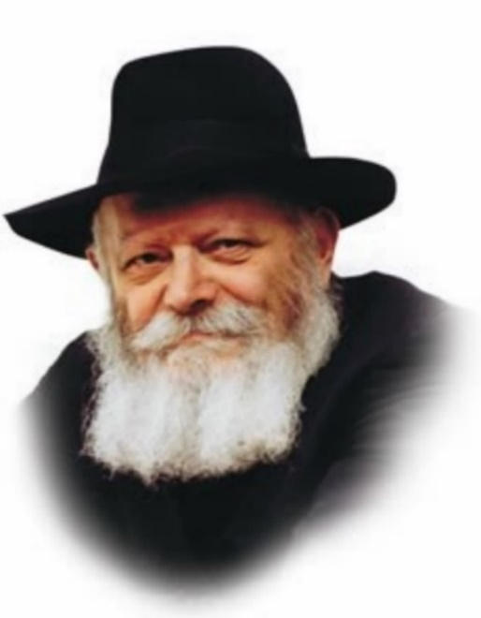

Yom Kippur, the Day of Atonement, is a day that is entirely dedicated to returning to G-d in teshuva (repentance). Among the many mitzvot involved in teshuva is the act of confession, as the Torah states, "You shall confess your sin." Indeed, this is the basis for the "Al Cheit" ("For the Sin of...") confessional recited on Yom Kippur, which enumerates the various sins a person may have committed.

In the Jerusalem Talmud, the question of whether or not this generalized confession is sufficient is debated. Rabbi Yehuda Ben Betaira maintains that in addition to reciting "Al Cheit," a detailed admission of personal sins is required. Rabbi Akiva, by contrast, opines that "It is not necessary to go into detail about one's deeds."

But what exactly is the crux of their argument? As the Tosefot explains, Rabbi Yehuda's insistence on a detailed account is for the purpose of arousing a deeper sense of remorse. The more a person is ashamed of his misdeeds, the deeper his repentance will be. Rabbi Akiva, however, takes the human factor into consideration, and asserts that if a person's individualized confession is overheard by others, "he might be suspected of other sins as well." In other words, the way people think about him might be negatively affected.

In essence, the argument revolves around where the emphasis should be placed: on the present, or on the future. When the present is emphasized - the fact that today is Yom Kippur - it is preferable to enumerate one's sins in order to achieve a higher level of teshuva. When the stress is on the future, the determining factor is to avoid any possible negative repercussions.

On a deeper level, there is another basis for their disagreement. Rabbi Yehuda views the individual in his present state, as one who is just beginning to do teshuva and draw closer to G-d. There are two basic motivations for doing teshuva: an initial stage, in which a person repents out of a sense of fear, and a higher level, on which the motivation is love for G-d. When a person enumerates his every little sin, it produces in him a stronger feeling of fear and awe of G-d.

Rabbi Akiva, however, looks at the larger picture, and anticipates that the person will eventually reach the higher level. In fact, his entire approach is to always perceive the hidden good in everything. When a person repents out of love for G-d, it makes no difference whether the sin is great or small; for he knows that every sin creates a distance between himself and G-d, and he will avoid committing even the smallest transgression.

*Reprinted from the Parshat Ha’azinu 5761/2000 edition of L’Chaim. (Adapted from Volume 24 of Likutei Sichot.)*

***You shall afflict your souls [i.e., fast] on the ninth day of the month at evening***

A question is asked in the Talmud (Yoma 81b): "Why does the Torah state 'on the ninth day,' when we actually fast on the tenth of the month, on Yom Kippur? To teach that a person who eats and drinks on the ninth [in preparation for the fast] is considered to have fasted on both the ninth and the tenth." And why is eating on the day before Yom Kippur deemed so important? For, eating for the sake of heaven is far more difficult than fasting for the sake of heaven. *(Malbim)*

*G-d's infinite capacity for forgiveness*

The dynamics of forgiveness between human beings are different from the dynamics of forgiveness between man and G-d. When a human being wrongs another person and apologizes, the wronged party will find it difficult to forgive him if he goes and does the exact same thing again; a third or fourth time. But this is not the case with G-d. Because His forgiveness is derived from the Divine attribute of mercy, which is endless and infinite, there is no difference between a first and thousandth offense, provided our repentance is sincere. *(Tanya)*

*Reprinted from the Parshat Ha’azinu 5761/2000 edition of L’Chaim.*